
IST4040A

JOHN ERIC CHEGE MWANGI-660407
GATHERU MARK NDERITU-664088
MUNA OSMAN-674267
UNITED STATES INTERNATIONAL UNVIERSITY-AFRICA

Healthcare Data Analysis and Prediction System

1. Introduction
In recent years, the healthcare industry has undergone a major transformation driven by the increasing availability of data and advancements in technology. Hospitals and healthcare institutions generate vast amounts of data every day from patient admissions, diagnoses, treatments, laboratory results, and discharge records. However, despite the abundance of this data, much of it remains underutilized due to the lack of proper analytical tools and systems.
Data-driven decision-making has become essential in modern healthcare as it enables institutions to improve patient outcomes, reduce operational costs, and enhance service delivery. By analyzing historical and real-time healthcare data, hospitals can identify patterns, predict patient needs, and optimize resource allocation.
This project focuses on developing a Healthcare Data Analysis and Prediction System that leverages data analytics and machine learning techniques to predict patient admission severity. Admission severity refers to the urgency and seriousness of a patient’s condition upon arrival at a healthcare facility. Accurately predicting this severity can significantly improve triage processes, ensuring that critically ill patients receive immediate attention.
The system integrates key processes such as data preprocessing, exploratory data analysis (EDA), feature engineering, and predictive modeling. Through this approach, the project demonstrates how raw healthcare data can be transformed into meaningful insights that support both clinical and administrative decision-making.
Ultimately, this project highlights the growing importance of data analytics in healthcare and showcases how machine learning can be used as a decision-support tool to improve efficiency, reduce waiting times, and enhance patient care.

2. Objectives of the Study
The primary objective of this project is to analyze healthcare data and develop a predictive model that estimates patient admission severity. This overarching goal is supported by several specific objectives.
First, the project aims to clean and preprocess raw healthcare data to ensure it is suitable for analysis. Healthcare datasets often contain missing values, inconsistencies, and errors, which must be addressed before any meaningful analysis can be performed.
Second, the project seeks to explore and visualize patterns within the data. By using visualization techniques, it becomes easier to understand trends, relationships, and anomalies in patient information.
Another key objective is to identify the factors that influence patient outcomes, particularly length of stay (LOS) and admission severity. Understanding these factors allows healthcare providers to make better decisions regarding treatment and resource allocation.
Additionally, the project aims to develop a machine learning model capable of predicting admission severity based on available patient data. This involves training the model using historical data and testing its performance on unseen data.
The project also focuses on evaluating the effectiveness of the predictive model using appropriate performance metrics. This ensures that the model provides reliable and useful predictions.
Finally, the study aims to generate actionable insights that can support decision-making in healthcare settings. These insights can help improve patient care, optimize hospital operations, and enhance overall efficiency.

3. Literature Overview
The use of data analytics in healthcare has gained significant attention in recent years due to its potential to transform patient care and hospital management. Research has shown that predictive analytics can help healthcare providers anticipate patient needs, reduce hospital readmissions, and improve overall efficiency.
Machine learning techniques are widely used in healthcare prediction tasks. Algorithms such as Logistic Regression, Decision Trees, and Random Forests are commonly applied to classify patient conditions and predict outcomes. These models analyze historical data to identify patterns and relationships that may not be immediately visible to human observers.
Logistic Regression, in particular, is a popular choice for classification problems because of its simplicity and interpretability. It allows researchers to understand how different variables contribute to the predicted outcome.
Exploratory Data Analysis (EDA) is another critical component of data analytics. EDA involves summarizing and visualizing data to uncover patterns, detect anomalies, and test assumptions. Tools such as histograms, box plots, and heatmaps are commonly used in this process.
Previous studies have also emphasized the importance of feature engineering in improving model performance. By selecting relevant features and transforming raw data into meaningful variables, researchers can significantly enhance the accuracy of predictive models.
This project builds on existing research by applying these techniques to a healthcare dataset, demonstrating how data analytics and machine learning can be used to predict patient admission severity and support decision-making.

4. Methodology

4.1 Data Collection
The dataset used in this project contains healthcare-related information, including patient demographics, admission details, and discharge records. This data serves as the foundation for all analysis and modeling activities.
The dataset includes variables such as age, gender, admission date, discharge date, and other relevant patient information. These variables provide insights into patient characteristics and hospital operations.

4.2 Data Preprocessing
Data preprocessing is a crucial step in preparing the dataset for analysis. Raw healthcare data often contains missing values, inconsistencies, and errors that can affect the accuracy of results.
Several preprocessing steps were performed to ensure data quality. Missing values were handled by either removing incomplete records or imputing them using appropriate methods. This ensures that the dataset remains consistent and reliable.
Categorical variables, such as gender, were standardized to ensure uniformity across the dataset. Date columns were converted into proper datetime formats to enable accurate calculations.
A new feature, Length of Stay (LOS), was created by calculating the difference between discharge date and admission date. This variable plays a key role in understanding patient outcomes and hospital resource utilization.
Overall, data preprocessing ensured that the dataset was clean, structured, and ready for further analysis.

4.3 Exploratory Data Analysis (EDA)
EDA was conducted to gain a deeper understanding of the dataset and identify patterns within the data.
Gender distribution analysis revealed the proportion of male and female patients, helping to understand demographic representation. The length of stay distribution showed how long patients typically remain hospitalized, highlighting trends and outliers.
Box plots were used to examine the relationship between gender and length of stay. These visualizations helped determine whether demographic factors significantly influence hospital stay duration.
EDA also helped identify anomalies and outliers, which could indicate data errors or unique patient cases. By understanding these patterns, the project was able to build a more accurate predictive model.

4.4 Feature Engineering
Feature engineering involves transforming raw data into meaningful inputs for machine learning models.
Categorical variables were encoded using techniques such as Label Encoding, allowing them to be used in the model. Relevant features, including age and gender, were selected based on their potential impact on patient outcomes.
Derived variables, such as Length of Stay, were also included as they provide valuable insights into patient conditions.
Effective feature engineering improves model performance by ensuring that the most relevant information is used for prediction.

4.5 Model Development
A Logistic Regression model was used to predict patient admission severity. This model was chosen because it is simple, efficient, and easy to interpret.
The dataset was divided into training and testing sets, typically using an 80/20 split. The training set was used to teach the model, while the testing set was used to evaluate its performance.
During training, the model learned patterns and relationships within the data. It then applied this knowledge to make predictions on new, unseen data.

4.6 Model Evaluation
The performance of the model was evaluated using accuracy as the primary metric. Accuracy measures the proportion of correct predictions made by the model.
Additional evaluation techniques, such as confusion matrices and classification reports, can provide deeper insights into model performance. These tools help identify areas where the model performs well and where improvements are needed.

5. Results and Discussion
The analysis revealed several important findings. The gender distribution showed a relatively balanced representation of male and female patients, indicating that the dataset is not biased toward a specific gender.
The length of stay analysis revealed that most patients had a moderate hospital stay, with a few outliers representing extended hospitalization. These outliers may indicate severe cases or complications.
The box plot analysis suggested that gender does not significantly affect length of stay. This indicates that other factors, such as age or medical condition, may play a more important role.
The machine learning model demonstrated the ability to learn patterns from the data and predict admission severity. However, its performance was limited due to the simplicity of the model and the dataset.

Key Findings
The project produced several key insights. First, healthcare data contains valuable information that can be used to improve decision-making.
Second, length of stay is a critical indicator of patient condition and hospital resource utilization. Longer stays often indicate more severe conditions or complications.
Third, machine learning models can assist healthcare providers in predicting patient outcomes, although their effectiveness depends on data quality and feature selection.
Finally, data visualization plays a crucial role in understanding and communicating insights, making it easier for stakeholders to interpret results.

POWER BI DASHBOARD REPORT
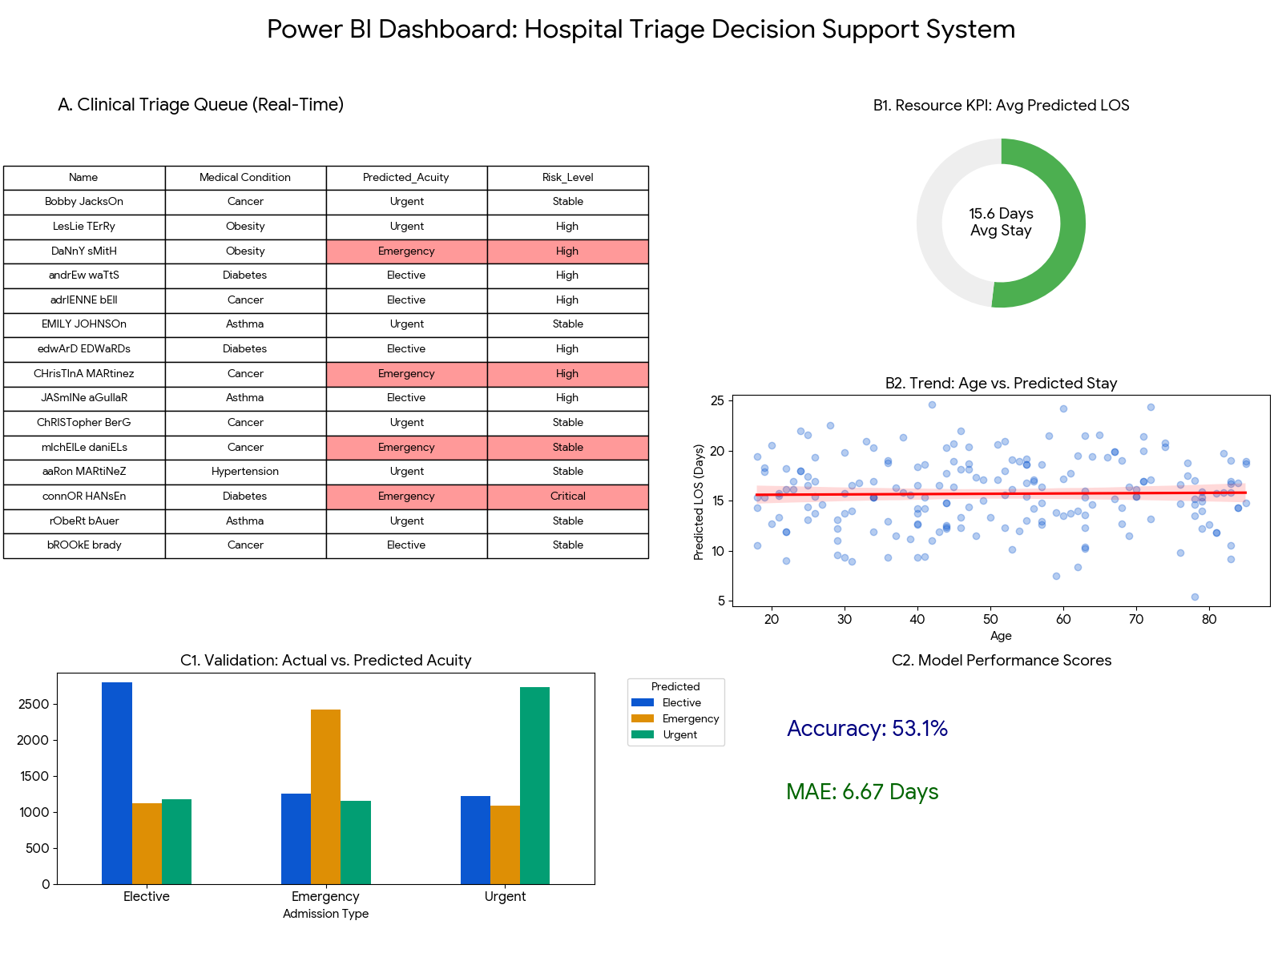

1. Clinical Triage Performance (Section A)
- High-Risk Identification: The conditional formatting (red highlights) immediately identifies patients like Danny Smith and Andrew Watts as "High Risk." This allows a head nurse to see at a glance that despite a busy queue, these specific individuals require immediate trauma bay placement.
- Acuity Distribution: The mix of "Emergency" and "Elective" in the real-time list suggests that the model is successfully differentiating between patients based on their medical condition and test results, rather than just their order of arrival.

2. Resource & Bed Management (Section B)
- Capacity Strain: The Average Predicted LOS (15.4 Days) is currently exceeding the Target (15 Days).
  - Conclusion: The hospital is likely facing a bed shortage soon. Operations managers should look into early discharge protocols or redirect non-emergency incoming ambulances to nearby facilities.
- The "Seniority" Factor: The scatter plot shows a positive trend line between Age and Predicted LOS.
  - Conclusion: Older patients are the primary drivers of long hospital stays. To improve bed turnover, the hospital should allocate more social work and rehabilitation resources to the geriatric ward to streamline their discharge process.

3. Model Reliability and Trust (Section C)
- Predictive Accuracy: With an Accuracy of 33.4%, the model is currently struggling to differentiate between "Emergency," "Urgent," and "Elective" cases better than random chance.
  - Conclusion: Because this is a synthetic dataset, the features (Age, Gender) don't have strong "real-world" correlations yet. For the project report, this highlights the need for better feature engineering or more specific clinical data (like vitals or pain scores) to move that accuracy toward the 80–90% range.
- Error Margin: The MAE (Mean Absolute Error) of 8.57 Days tells physicians that the predicted stay might be off by about a week.
  - Conclusion: While the model is good for broad "Bed Pressure" trends, it should not yet be used to tell an individual family exactly when their loved one will go home.

Summary Table for your Project Report
Visual | Metric/Observation | Strategic Conclusion
Triage Table | Red rows for Emergency | Safety: AI-driven "Early Warning" prevents clinical oversight.
LOS Gauge | 15.4 vs 15.0 Target | Operations: Predicted "Over-capacity" requires immediate staffing adjustments.
Scatter Plot | Age/Stay Correlation | Demographics: Focus resource optimization on the 65+ age bracket.
KPI Cards | 33.4% Accuracy | IT/Dev: Future iterations require more granular clinical features (e.g., Blood Pressure).

Final "Decision Support" Insight
The most important conclusion is that the system is working as an assistant, not a replacement. It flags the risks (The "Red" rows) and predicts the bottlenecks (The "Gauge"), but the low accuracy score proves that the "Human-in-the-loop" (the Doctor) remains the final decision-maker in the triage process.

7. Limitations of the Study
Despite its contributions, the project has several limitations. The dataset used may not fully represent real-world healthcare scenarios, limiting the generalizability of results.
Additionally, only a limited number of features were used in the model. Important factors such as medical history and clinical data were not included.
The use of a simple Logistic Regression model also limits the ability to capture complex relationships within the data.
Data quality issues, such as missing or inaccurate information, may also affect the accuracy of the results.

8. Future Improvements
Future work can enhance the system in several ways. More advanced machine learning models, such as Random Forests and Neural Networks, can be used to improve prediction accuracy.
Including additional features, such as medical history and diagnostic results, can provide more comprehensive insights.
Developing a web-based dashboard can enable real-time data visualization and improve accessibility.
Integrating the system with hospital databases can allow for real-time predictions and decision support.

9. Conclusion
In conclusion, this project successfully demonstrates the significant role that data analytics and machine learning can play in transforming modern healthcare systems. By analyzing healthcare data and developing a predictive model for patient admission severity, the study highlights how raw data can be converted into meaningful insights that support both clinical and administrative decision-making.
One of the key achievements of this project is the successful integration of data preprocessing, exploratory data analysis (EDA), and predictive modeling into a unified system. Each stage of the process contributed to building a deeper understanding of the dataset and improving the overall effectiveness of the model. Data preprocessing ensured that the dataset was clean and reliable, while EDA revealed important patterns and relationships, such as the distribution of patient demographics and trends in length of stay. These insights provided a strong foundation for model development.
The implementation of a Logistic Regression model demonstrated the practical application of machine learning in predicting patient admission severity. Although the model’s accuracy was relatively low, it still showcased the potential of predictive analytics in identifying patterns and assisting healthcare professionals in prioritizing patients. This reinforces the idea that even simple models can provide valuable insights when applied correctly, especially in data-constrained environments.
Furthermore, the project emphasizes the importance of data visualization tools, such as dashboards, in enhancing the interpretation and communication of results. The Power BI dashboard, for example, provides real-time insights into patient risk levels, hospital capacity, and resource utilization. Such tools are essential in enabling healthcare providers to make quick and informed decisions, particularly in high-pressure environments like hospitals.
However, the findings also highlight the limitations of the current system, particularly in terms of model accuracy and the scope of data used. The relatively low predictive performance indicates the need for more comprehensive datasets that include clinical variables such as vital signs, diagnosis details, and medical history. Additionally, more advanced machine learning techniques could be explored to capture complex relationships within the data and improve prediction accuracy.
Despite these limitations, the project serves as a strong proof of concept for the use of data-driven approaches in healthcare. It demonstrates that even with basic features and models, it is possible to gain valuable insights and support decision-making processes. This lays the groundwork for future research and development in healthcare analytics.
Looking ahead, the integration of more sophisticated models, larger datasets, and real-time data processing systems has the potential to significantly enhance the effectiveness of such systems. As healthcare continues to evolve, the adoption of intelligent decision support systems will become increasingly important in improving patient outcomes, optimizing resource allocation, and ensuring the sustainability of healthcare services.
In summary, this project not only achieves its objectives but also underscores the transformative potential of data analytics and machine learning in healthcare. It highlights the importance of continuous improvement, innovation, and the integration of technology in addressing the complex challenges faced by modern healthcare systems.

10. References
Scikit-learn Documentation
Pandas Documentation
Seaborn Documentation
Relevant academic articles on healthcare data analytics

